

Structural Design

(Inside View)

**Vertical corrugation**

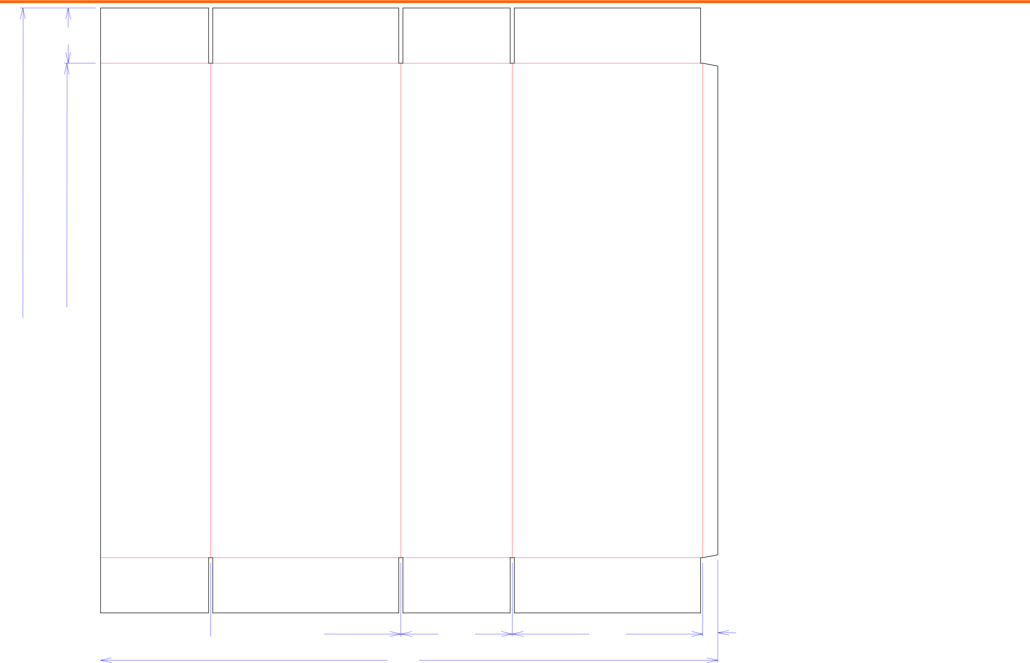

5

545*/*8 445*/*8

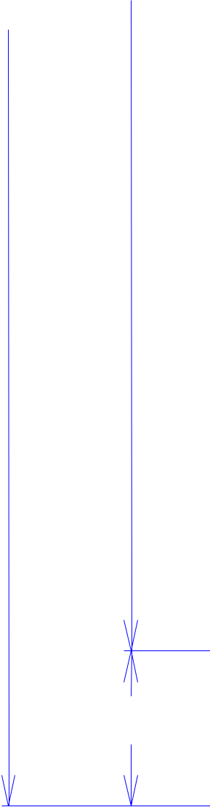

Design#:

Customer:

**Signature Snacks**

Description:

**9906/1**

**SINGLE-OUT DRAWING**

Qty/Unit:

Style: **RSC**

Board: **32 C K (CKK32)**

I.D. : **17 x 9+7/8 x 44+5/16**

Area of Blank - Waste : **20.96 sq. ft.**

Waste on Blank : **0.89%**

Finished Piece Weight: **2.11 lbs./959.15g**

Over-all Blank: **54+5/8 x 55+3/4**

Notes:

5

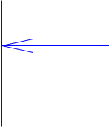 915*/*16  173*/*16

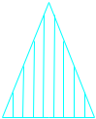

Cut Crease Crease with Matrix



|  |  |  |  |
| --- | --- | --- | --- |
|  | 101*/*16 | 173*/*16 | 13*/*8 |
| 553*/*4 |  |  |  |
| Cut Crease | Half Knife Cut | Tear Tape | Perforation |



**Changed Routing to WARD FFG Per Arli S - BR 3/31/15**

Revision Info: **[A] 02/21/2007**

**adjust depth for better pallet utilization Rev. by Doug Bowers**

Designer: **Henry Raymond**

Designright and Copyright of DS Smith Corrugated Packaging Ltd. This technical Specification is subject to Manufacturing tolerances. Drawing dimensions shown are crease to crease. Date printed: 02/11/2021